**Uji Kompetensi Unit 15 & 18**

**OOP PBO**

1. Terdapat 3 class :

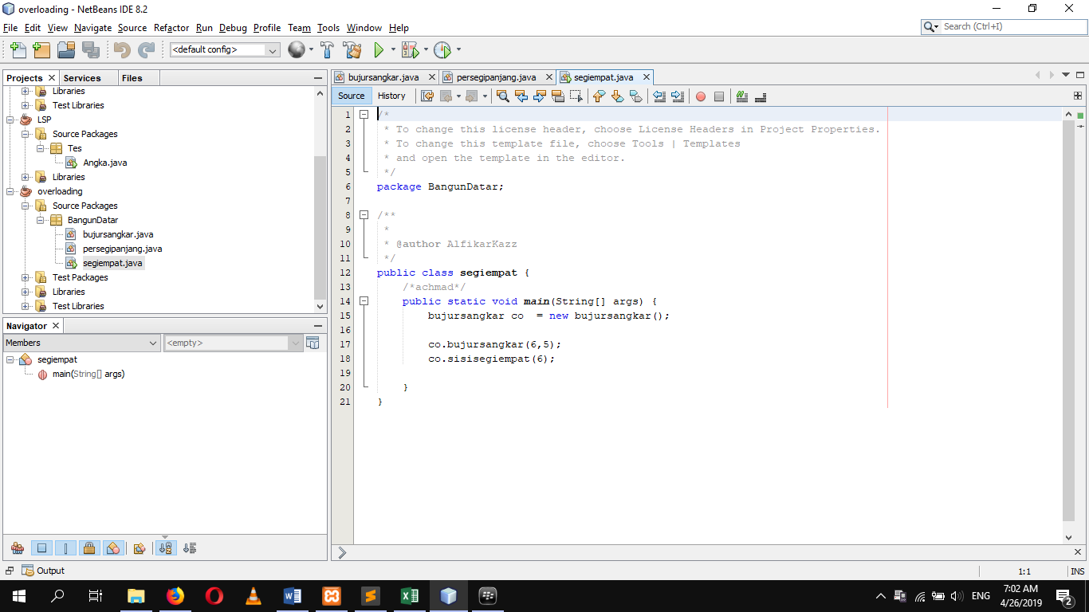

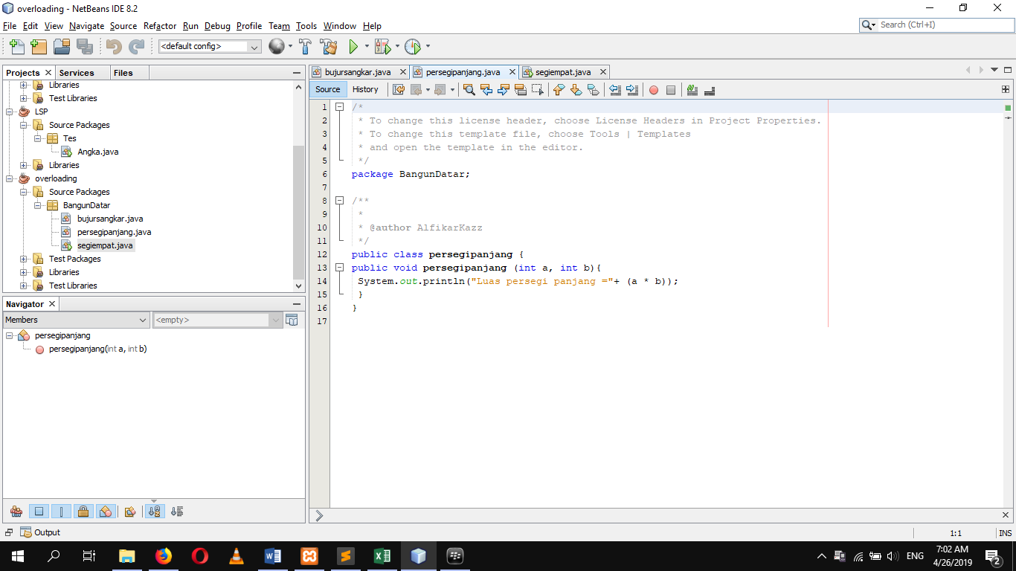

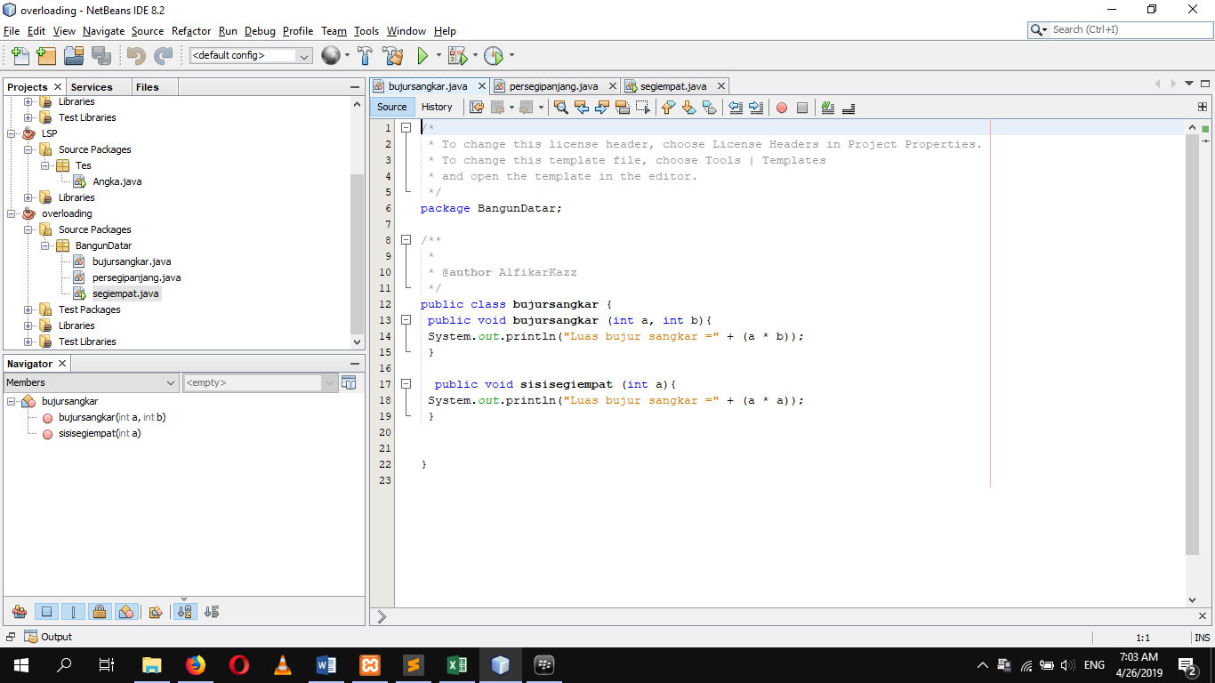

2. Output

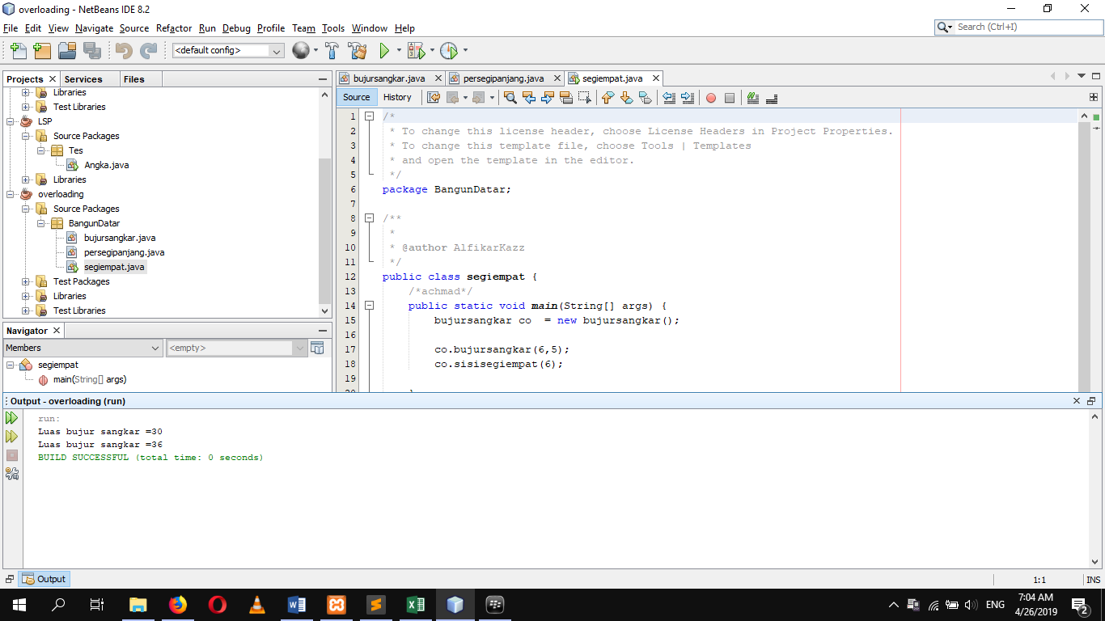

3. Dokumentasi program CLICK HERE